Software Requirements Specification

for

NexaPlay Game Launcher

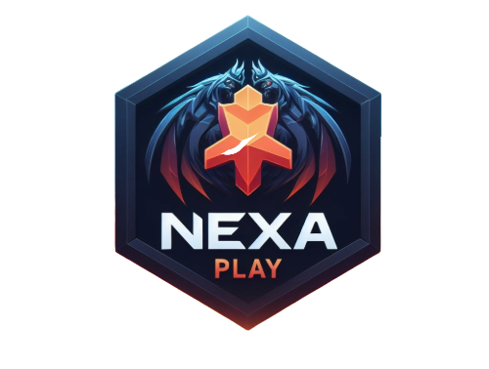

**Prepared by**

**Bassel Ashraf 221101208**

**Amin Ayssar 221101207**

**Marten Magdy 221101221**

**King Salman International University**

**5/16/2024**

**Table of Contents**

**Table of Contents ii**

**Revision History ii**

**1. Introduction 1**

1.1 Purpose 1

1.2 Document Conventions 1

1.3 Intended Audience and Reading Suggestions 1

1.4 Product Scope 1

1.5 References 1

**2. Overall Description 2**

2.1 Product Perspective 2

2.2 Product Functions 2

2.3 User Classes and Characteristics 2

2.4 Operating Environment 2

2.5 Design and Implementation Constraints 2

2.6 User Documentation 2

2.7 Assumptions and Dependencies 3

**3. External Interface Requirements 3**

3.1 User Interfaces 3

3.2 Hardware Interfaces 3

3.3 Software Interfaces 3

3.4 Communications Interfaces 3

**4. System Features 4**

4.1 System Feature 1 4

4.2 System Feature 2 (and so on) 4

**5. Other Nonfunctional Requirements 4**

5.1 Performance Requirements 4

5.2 Safety Requirements 5

5.3 Security Requirements 5

5.4 Software Quality Attributes 5

5.5 Business Rules 5

**6. Other Requirements 5**

**Appendix A: Glossary 5**

**Appendix B: Analysis Models 5**

**Appendix C: To Be Determined List 6**

# Introduction

## Purpose

*The purpose of this Software Requirements Specification (SRS) document is to present a detailed description of the NexaPlay software product, including its functionality, interface, performance, and development requirements. This document is intended for both the stakeholders and the development team as it serves as a reference for the project's technical specifications and guidelines.*

*This SRS covers the complete software development lifecycle of NexaPlay, version 1.0. It encompasses the system's registration and login modules, the store page featuring a curated selection of five games, and the library management system that allows users to store, launch, and play their chosen games. This document details the requirements for the entire system, ensuring that all components work cohesively to provide an optimal user experience.*

## Document Conventions

*This Software Requirements Specification (SRS) document follows standardized typographical conventions to ensure clarity and consistency throughout. The following conventions have been adopted:*

*1. Fonts: The body text of this document is presented in 11-point 'Arial' font, while headings are distinguished in 14-point 'Times Bold'. This distinction aids in the hierarchical organization and readability of the document.*

*2. Highlighting: Key terms and requirement identifiers are highlighted in bold to facilitate quick reference. Additionally, new terms and definitions are italicized upon their first occurrence to emphasize their importance and definition.*

*3. Prioritization: Unless otherwise stated, priorities for high-level requirements are inherited by their detailed counterparts. This approach simplifies the prioritization process and ensures that all related requirements are addressed with an appropriate level of focus.*

*4. Requirement Statements: Each requirement statement is uniquely identified by a sequential numbering system, which serves as a reference point throughout the development process.*

*5. Change Management: Any amendments to the document will be documented in a 'Revision History' table at the beginning of the document, detailing the nature of the change, the author, and the date of the amendment.*

*By adhering to these conventions, the SRS document aims to deliver a clear, structured, and easily navigable framework for the development and assessment of the "NexaPlay" gaming store and launcher project.*

## Intended Audience and Reading Suggestions

*The Software Requirements Specification (SRS) for NexaPlay is a comprehensive document intended for a diverse audience. Primarily, it is designed for software engineers who will use it as a guide for development and maintenance. Project managers will find it useful for planning and tracking progress, while marketing staff can extract feature lists and selling points for promotional activities. End-users, particularly gamers, can refer to the user requirements section to understand the functionalities offered by NexaPlay. Testers will rely on the SRS for creating test cases, and documentation writers will use it as a foundation for user manuals and help guides.*

*The SRS is organized into an overview of NexaPlay, detailed descriptions of system functionalities, user interface designs, and technical requirements. It begins with an introduction to the project, followed by a detailed description of the system's purpose, scope, and intended use. The document then delves into specific requirements, categorized by user, system, and non-functional requirements, and concludes with appendices and an index.*

*Readers are advised to start with the overview to gain a foundational understanding of NexaPlay. Developers and testers should focus on the functional requirements and system architecture sections. Project managers and documentation writers may find the project scope and objectives sections most relevant, while marketing staff should review the feature summaries and user demographics. Each section is designed to be self-contained, allowing readers to focus on the information most pertinent to their role.*

## Product Scope

*NexaPlay is an innovative software engineering project designed to provide a seamless gaming experience by integrating a store and launcher into a single platform. The primary objective of NexaPlay is to simplify the process of purchasing, managing, and playing games for users. With its user-friendly register and login interface, NexaPlay ensures secure access to a curated selection of five high-quality games, which users can effortlessly add to their personal library. The platform's store page is not only a gateway to discover and acquire new games but also serves as a launchpad, enabling users to start their gaming sessions with ease. The strategic goal of NexaPlay is to enhance user engagement and satisfaction by offering a streamlined gaming service that aligns with the corporate vision of delivering top-tier entertainment solutions. By focusing on user-centric design and functionality, NexaPlay aims to establish itself as a leader in the digital gaming market, contributing to the broader business strategy of expanding digital content offerings and fostering a robust gaming community.*

## References

[*UML for NexaPlay*](https://lucid.app/lucidchart/959263f7-83b7-4c24-bcee-a23269f1c874/edit?viewport_loc=371%2C-2261%2C3389%2C1661%2C0_0&invitationId=inv_d9c38810-fb8c-44be-8d33-bf2385342a46)

# Overall Description

## Product Perspective

*NexaPlay is a self-contained software product designed to serve as a comprehensive gaming store and launcher. It is not a follow-on member of a product family, nor is it a replacement for existing systems. Instead, NexaPlay stands as a new entry in the market, aiming to provide a seamless user experience from registration to gameplay. The software facilitates user engagement through a straightforward registration and login process, followed by access to a curated store page featuring a selection of five games. Users can personalize their experience by adding desired games to their library, which also serves as the launchpad for gameplay.*

*The product is envisioned to operate autonomously but has been designed with the potential to integrate into larger gaming ecosystems in the future. The SRS for NexaPlay should detail the software's capabilities, focusing on user interface design, security protocols for user data, and the robustness of the game-launching mechanism. It should also outline the system's scalability to accommodate a growing library of games and an increasing user base. Interfaces between NexaPlay and potential external systems, such as social media platforms for sharing gaming achievements or payment gateways for in-app purchases, must be clearly defined to ensure compatibility and functionality within the broader digital infrastructure. A diagrammatic representation of NexaPlay's architecture would illustrate the main components, such as the user authentication module, the store management system, the library interface, and the game launcher, along with their interconnections and external interfaces.*

## Product Functions

*The NexaPlay software engineering project encompasses a comprehensive suite of functions to provide a seamless gaming experience. The primary functions include:*

*1. **User Registration and Authentication**: Allows new users to create an account and existing users to securely log in.*

*2. **Game Storefront**: Displays a curated selection of games, enabling users to browse and select titles for purchase.*

*3. **Library Management**: Provides users with the ability to add purchased games to their personal library for easy access.*

*4. **Game Launcher**: Facilitates the launching and playing of games directly from the user's library.*

*These functions are designed to work in unison, creating an intuitive flow from user registration to game acquisition and play. The user-centric design ensures that gamers can easily navigate through the platform, making game management and access straightforward and efficient. The upcoming detailed sections of the SRS will delve into the specifics of each function, outlining the technical requirements and the interactions between different components of the system.*

## User Classes and Characteristics

*In the Software Requirements Specification (SRS) for NexaPlay, the anticipated user classes can be broadly categorized as follows:*

*1. Casual Gamers: This class includes users who play games infrequently and prefer a straightforward, user-friendly interface. They may not be technically savvy and would likely use basic functions such as browsing the store, purchasing games, and playing them without delving into more complex features.*

*2. Regular Gamers: Regular gamers use NexaPlay more frequently and are familiar with its various functions. They require a stable and efficient system with features like cloud saves, achievement tracking, and social sharing options. They might also be interested in community features and forums.*

*3. Hardcore Gamers: These users are deeply engaged with the platform, often utilizing advanced features such as mod support, in-depth game analytics, and customization options. They demand high performance and may have higher-end hardware that requires optimization from the software.*

*4. Developers: Developers use NexaPlay to distribute their games. They need access to robust analytics, marketing tools, and support for different monetization strategies. Their technical expertise is high, and they require detailed documentation and responsive support.*

*5. Administrators: Administrators are responsible for the maintenance and moderation of NexaPlay. They have the highest level of access and control over the platform, dealing with security, user management, content regulation, and ensuring the smooth operation of all services.*

*The most critical user classes for NexaPlay's success are likely the Regular and Hardcore Gamers, as their engagement levels directly influence the platform's activity and reputation. Casual Gamers are also important for the volume, while Developers and Administrators are essential for content provision and platform integrity, respectively. Each class has unique requirements that must be carefully considered in the SRS to ensure a comprehensive and inclusive gaming platform.*

## Operating Environment

*The software will be compatible with Windows 10 and later versions and with macOS 10.13 (High Sierra) and later versions. The software does not require any other applications to function.*

*The application does not require an internet connection after installation.*

## Design and Implementation Constraints

*2.5.1 Corporate or Regulatory Policies*

*The software must comply with relevant data protection regulations (e.g., GDPR for European users) and adhere to corporate policies regarding user data privacy and security.*

*2.5.2 Hardware Limitations*

*The software will operate on standard personal computers (PCs) with minimum hardware requirements:*

* *Processor: Dual-core CPU*
* *Ram: 4 GB*
* *Storage: At least 200 MB of available disk space*

*The software should be optimized to ensure efficient performance within these hardware limitations.*

*2.5.3 Interfaces to Other Applications*

*NexaPlay does not interface with any external applications or services.*

*2.5.4 Parallel Operations*

*The software does not require support for parallel operations or multi-threading beyond what is necessary for responsive UI interactions.*

*2.5.5 Communications Protocols*

*The software operates as a standalone application does not require network communications or protocols, and does not require any internet connection after installation.*

*Additional Considerations:*

* *The software should peacefully coexist with antivirus programs and other security software.*
* *The software should not conflict with other applications running on the same system.*

## User Documentation

*None.*

## Assumptions and Dependencies

1. *Assumptions:*

* *Operating System Compatibility: It is assumed that NexaPlay will run smoothly on Windows 10 and later versions, as well as macOS 10.13 (High Sierra) and later versions. If future updates to these operating systems introduce compatibility issues, the software's functionality could be affected.*
* *Hardware Specifications: The software is designed to operate on PCs with a minimum of a dual-core CPU, 4 GB RAM, and 200 MB of available disk space. It is assumed that users' hardware meets these specifications. Performance may be degraded on systems that do not meet these requirements.*

1. *Dependencies:*

* *Operating System Updates: The project depends on the stability and backward compatibility of the Windows and macOS operating systems. Major updates or changes to these operating systems that affect application compatibility could require significant adjustments to NexaPlay.*
* *Hardware Compatibility: NexaPlay’s performance and compatibility depend on the continued support of standard PC hardware configurations. Changes in hardware standards or the introduction of new hardware that is incompatible with current software configurations could affect NexaPlay’s usability.*
* *Third-Party Libraries: The software might utilize third-party libraries for specific functionalities, such as image handling or user interface components. The project depends on the stability and continued support of these libraries. If these libraries are discontinued or have critical bugs, it may impact NexaPlay’s functionality.*

1. *The Vision*

* *Provide an intuitive and user-friendly video game store application that allows users to browse and manage their game libraries seamlessly. The application aims to deliver a straightforward and efficient experience for users to add games to their library, and launch games directly from their PC without the need for internet connectivity.*

# External Interface Requirements

## User Interfaces

*The user interface for NexaPlay is designed to be intuitive and user-friendly, ensuring a seamless experience for users. The software includes several key components, each with distinct logical characteristics.*

1. *Registration Tab:*

* *Logical Characteristics: This initial screen allows users to sign up or sign in. It includes fields for username, email, and password, along with a submit button to complete the registration or login process. Error messages are displayed in red text near the input fields, providing clear guidance on how to correct any issues (e.g., "Password must be at least 8 characters").*
* *Screen Layout: The layout is straightforward with input fields stacked vertically, followed by the submit button. Consistent spacing and alignment ensure a clean look.*

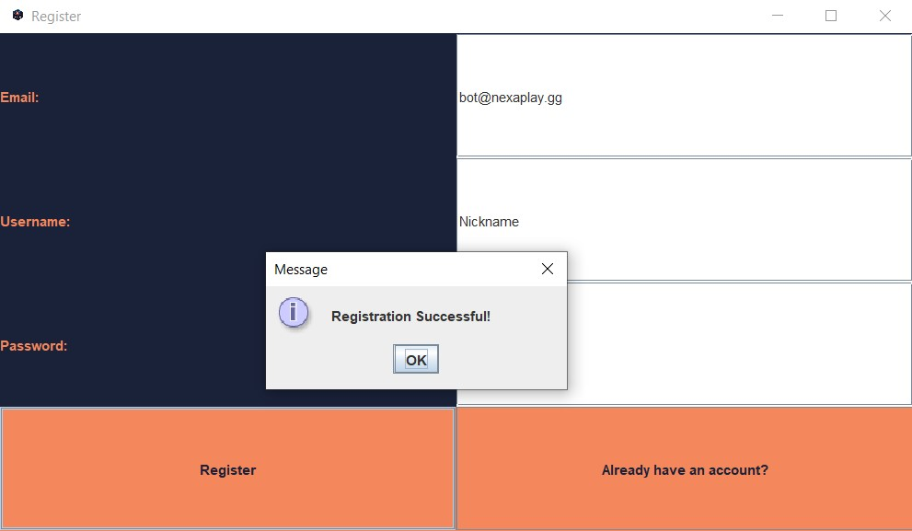

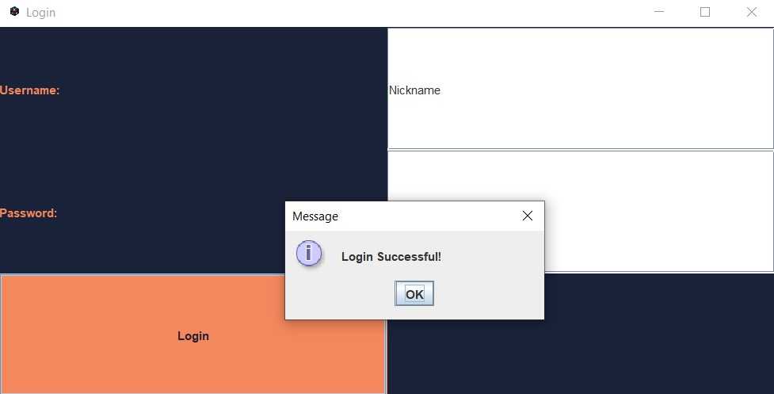

1. *Store Tab:*

* *Logical Characteristics: This tab displays a list of 5 games, each represented by a thumbnail image and title. Clicking on a game directs the user to the Game Details View.*
* *Screen Layout: The games are displayed in a grid format for easy browsing. Each game entry includes a clickable area that leads to more detailed information.*
* *Standard Functions: A consistent navigation bar is present at the top of the screen, allowing users to switch between the Store and Library tabs easily.*

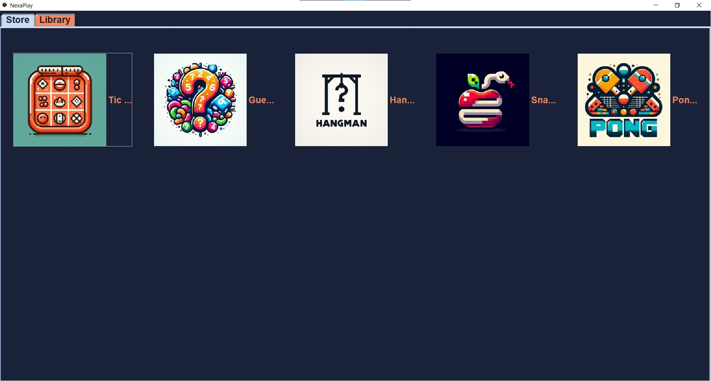

1. *Library Tab:*

* *Logical Characteristics: This tab displays the games that the user has added to their library. Each game is represented by a thumbnail image. Clicking on a game logo launches the game itself.*
* *Screen Layout: Similar to the Store tab, the games are displayed in a grid format. Each game entry is clickable to launch the game.*
* *Standard Functions: The navigation bar and help button are consistent with the Store tab. Clicking on a game logo directly launches the game.*

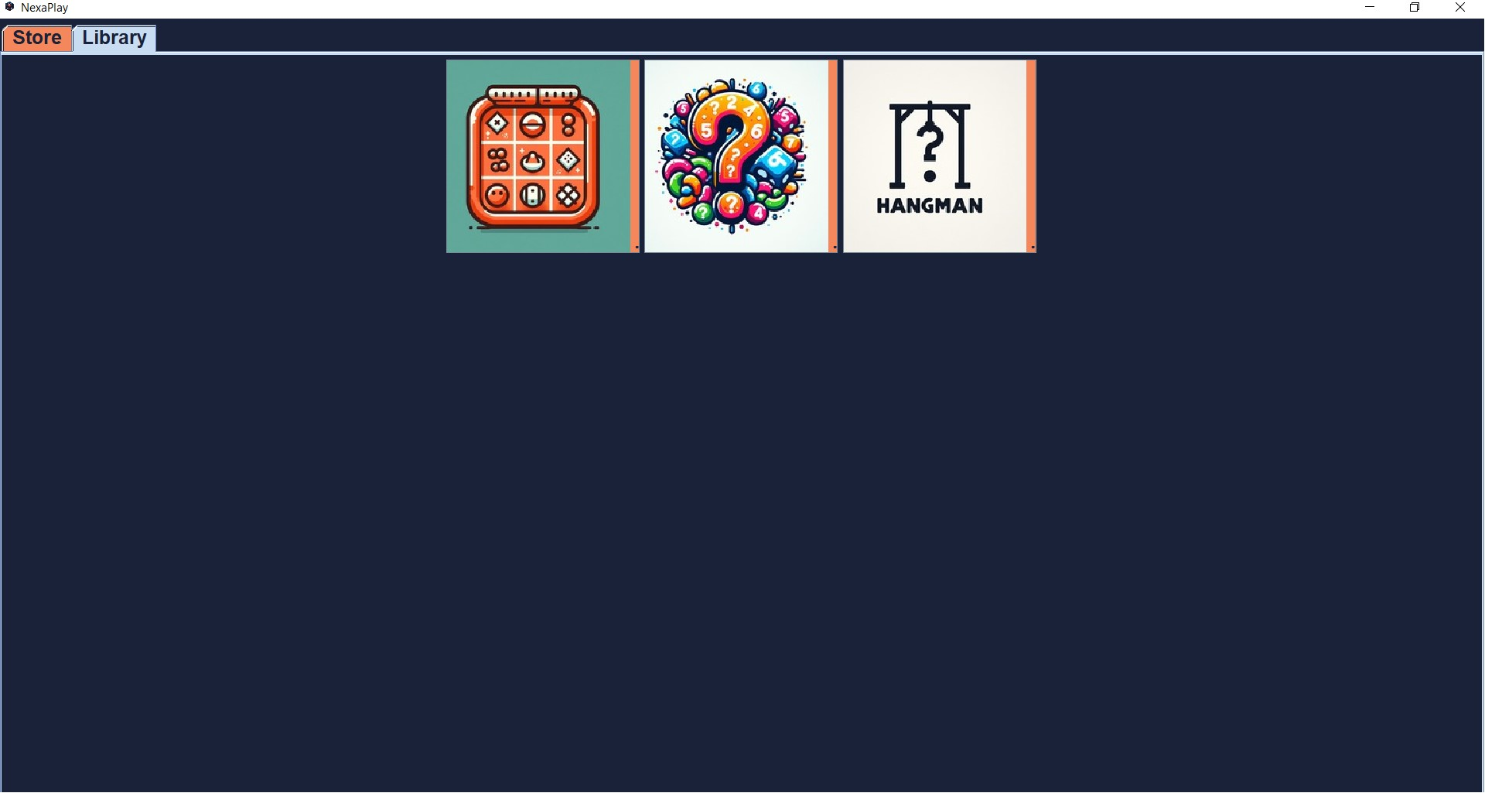

1. *User Interface Components:*

* *Registration Form: Needed for user authentication.*
* *Game List (Store and Library): For browsing and managing games.*
* *Game Details View: For viewing detailed game information and adding games to the library.*
* *Add to Library Button: For adding games to the user's library.*
* *Game Launch Functionality: For launching games from the Library tab.*

1. *GUI Standards and Conventions:*

* *Consistency: All tabs and screens follow a uniform design style with consistent fonts, colors, and button styles.*
* *Navigation: Clear labels and breadcrumb trails where necessary.*
* *Error Messages: Displayed in red text near the relevant input field, providing clear instructions on how to correct errors.*

## Hardware Interfaces

*NexaPlay operates on standard personal computers (PCs) with the following characteristics: a dual-core CPU or better and requires a minimum of 4 GB RAM and at least 200 MB of available disk space. It supports a minimum display resolution of 1280x720. The primary input devices are the keyboard and mouse, and the output device is the display monitor.*

*NexaPlay does not directly control or interact with hardware devices beyond standard input and output operations, ensuring compatibility and ease of use on standard PC hardware.*

## Software Interfaces

*NexaPlay connects to various software components as follows:*

*Data items and messages handled by the software include incoming data from user inputs for registration and game selection and outgoing data such as game details and library updates. The primary purpose of these data transactions is to facilitate user authentication, game browsing, and library management.*

## Communications Interfaces

*NexaPlay does not require network communication for its core functionality. Data security is maintained through local storage encryption for user authentication data. Since there are no external communication protocols used, network security considerations are not applicable.*

*These external interface requirements ensure that NexaPlay operates efficiently within the defined environment, providing a seamless user experience through well-defined user, hardware, and software interfaces.*

# System Features

*This section describes the functional requirements for NexaPlay, organized by system features. These features represent the major services provided by the product.*

## Registration Tab

4.1.1 Description and Priority

*Allows users to sign up or sign in to access the application's features. High priority.*

4.1.2 Stimulus/Response Sequences

*User Action: The user opens the application.*

*System Response: Display the Registration tab.*

*User Action: The user signs up or signs in.*

*System Response: Redirect to the home page*

4.1.3 Functional Requirements

REQ-1: The system shall display a Registration tab on startup.

REQ-2: The system shall provide options for signing up or signing in.

REQ-3: The system shall redirect the user to the home page upon successful authentication.

## Store Tab

4.2.1 Description and Priority

*Displays a list of 5 games available for browsing. High priority.*

4.2.2 Stimulus/Response Sequences

*User Action: The user opens the Store tab.*

*System Response: Display the list of 5 available games.*

4.1.3 Functional Requirements

*REQ-4: The system shall display 5 games in the Store tab.*

*REQ-5: Each game shall have a link to a detailed view.*

## 4.3 Game Details View

4.3.1 Description and Priority

*Displays detailed information about a selected game, including 3 images and an "Add to Library" button. High priority.*

4.3.2 Stimulus/Response Sequences

*User Action: The user clicks on a game in the Store tab.*

*System Response: Display detailed view with images and "Add to Library" button.*

4.3.3 Functional Requirements

*REQ-6: The system shall display 3 images for each game in the detailed view.*

*REQ-7: The system shall include an "Add to Library" button in the detailed view.*

*REQ-8: When the "Add to Library" button is clicked, the game shall be added to the Library tab.*

## 4.4 Library Tab

4.4.1 Description and Priority

*Displays games that the user has added from the Store. Allows launching of games directly from the Library. High priority.*

4.4.2 Stimulus/Response Sequences

*User Action: The user opens the Library tab.*

*System Response: Display the list of games added by the user.*

*User Action: The user clicks on a game logo in the Library tab.*

*System Response: Launch the selected game.*

4.4.3 Functional Requirements

*REQ-9: The system shall display a list of games added by the user in the Library tab.*

*REQ-10: Each game in the Library shall have a link to its detailed view.*

*REQ-11: The system shall allow launching a game by clicking on its logo in the Library tab.*

# Other Nonfunctional Requirements

## Performance Requirements

*REQ-12: Average response time for user actions shall be under 1 second.*

## Safety Requirements

*None.*

## Security Requirements

*REQ-13: The system shall ensure basic protection of user data.*

## Software Quality Attributes

*Usability: The UI shall be simple and intuitive.*

*Reliability: The system shall have an uptime of 99%.*

## Business Rules

*None.*

# Other Requirements

*None.*

**Appendix A: Glossary**

*UI: User Interface.  
GUI: Graphical User Interface.*

**Appendix B: Analysis Models**

*None.*

**Appendix C: To Be Determined List**

*None.*